Pizza outlet analysis

**Basic Questions**

. -- Retrieve the total number of orders placed --

select count(order_id) as total_orders from orders;

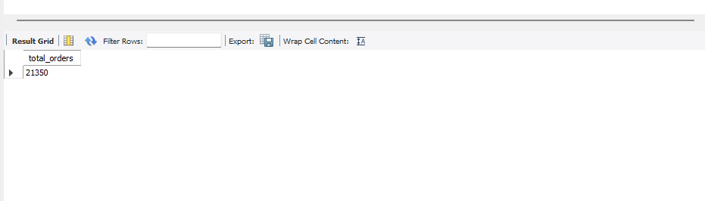

-- Calculate the total revenue generated from pizza sales--

SELECT

ROUND(SUM(order_details.quantity * pizzas.price), 2) AS total_sales

FROM order_details

JOIN pizzas

ON pizzas.pizza_id = order_details.pizza_id;

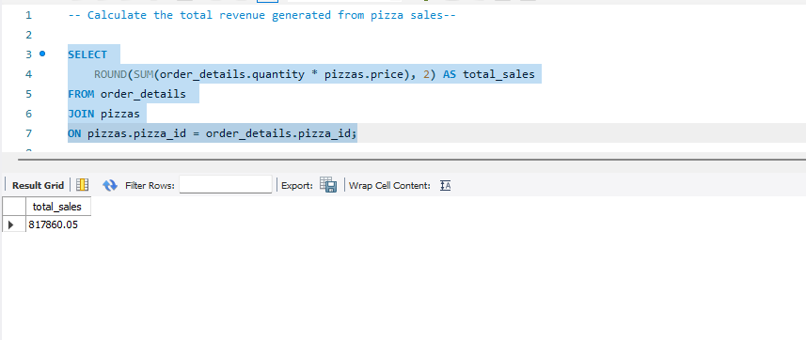

-- Identify the highesh priced pizza--

SELECT pizza_types.name, pizzas.price

from pizza_types join pizzas

on pizza_types.pizza_type_id = pizzas.pizza_type_id

order by pizzas.price desc limit 1;

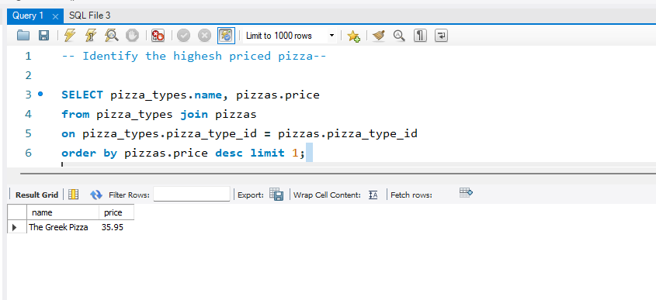

-- Identify the most common pizza size ordered--

SELECT

pizzas.size,

COUNT(order_details.order_details_id) AS order_count

FROM

pizzas

JOIN

order_details ON pizzas.pizza_id = order_details.pizza_id

GROUP BY pizzas.size

ORDER BY order_count DESC;

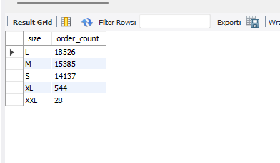

-- List the top 5 most ordered pizza types along with their quantity--

SELECT pizza_types.name, SUM(order_details.quantity) AS quantity

FROM pizza_types

JOIN pizzas ON pizza_types.pizza_type_id = pizzas.pizza_type_id

JOIN order_details ON order_details.pizza_id = pizzas.pizza_id

GROUP BY pizza_types.name

ORDER BY quantity DESC

LIMIT 5;

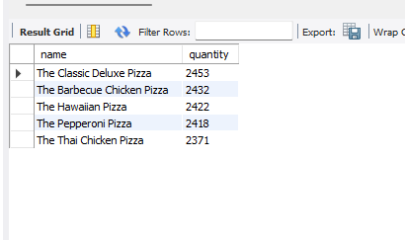

**Intermediate question**

-- Join the necessary tables to find the total quantity of each pizza category ordered--

SELECT pizza_types.category,

SUM(order_details.quantity) AS quantity

FROM pizza_types

JOIN pizzas ON pizza_types.pizza_type_id = pizzas.pizza_type_id

JOIN order_details ON order_details.pizza_id = pizzas.pizza_id

GROUP BY pizza_types.category

ORDER BY quantity DESC;

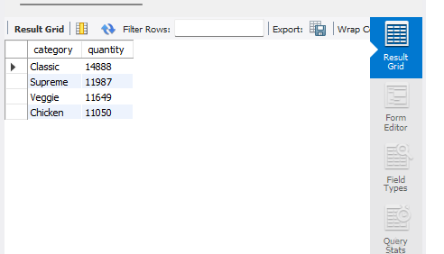

-- Determine the distribution of orders by hour of the day--

SELECT

HOUR(order_time) AS hour, COUNT(order_id) AS order_count

FROM

orders

GROUP BY HOUR(order_time);

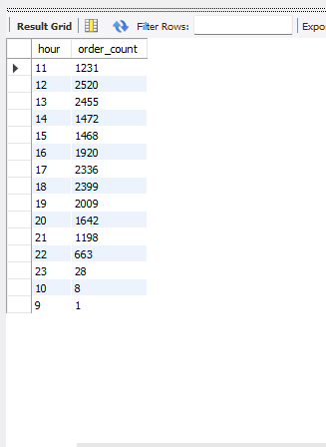

-- Join relevant tables to find the category wise distribution of pizzas--

select category , count(name) from pizza_types

group by category;

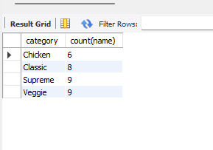

-- group the orders by date and calculate the average number of pizzas ordered per day--

select round(avg(quantity),0) from

(select orders.order_date, sum(order_details.quantity) as quantity

from orders join order_details

on orders.order_id = order_details.order_id

group by orders.order_date) as order_quantity ;

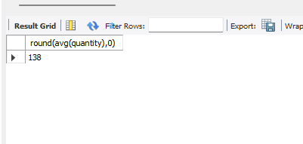

SELECT

ROUND(AVG(quantity), 0) AS avg_pizza_ordered_per_day

FROM

(SELECT

orders.order_date, SUM(order_details.quantity) AS quantity

FROM

orders

JOIN order_details ON orders.order_id = order_details.order_id

GROUP BY orders.order_date) AS order_quantity;

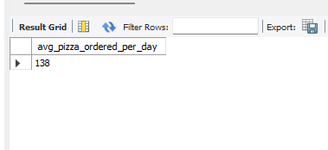

-- Determine the top 3 most ordered pizza types based on revenue -

SELECT pizza_types.name,

SUM(order_details.quantity * pizzas.price) AS revenue

FROM pizza_types

JOIN pizzas ON pizza_types.pizza_type_id = pizzas.pizza_type_id

JOIN order_details ON order_details.pizza_id = pizzas.pizza_id

GROUP BY pizza_types.name

ORDER BY revenue DESC

LIMIT 3;

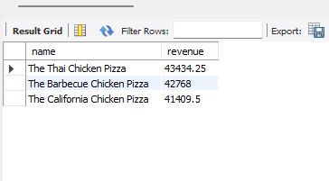

**Advanced analysis**

-- Calculate the percentage contribution of each pizza type to total revenue --

SELECT pizza_types.category,

ROUND(SUM(order_details.quantity * pizzas.price) /

(SELECT SUM(order_details.quantity * pizzas.price)

FROM order_details

JOIN pizzas ON pizzas.pizza_id = order_details.pizza_id) * 100, 2) AS revenue

FROM pizza_types

JOIN pizzas ON pizza_types.pizza_type_id = pizzas.pizza_type_id

JOIN order_details ON order_details.pizza_id = pizzas.pizza_id

GROUP BY pizza_types.category

ORDER BY revenue DESC;

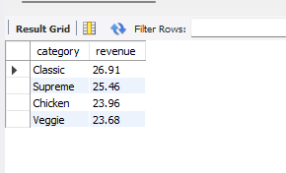

-- analyze the cumulative revenue generated over time --

SELECT order_date,

SUM(revenue) OVER (ORDER BY order_date) AS revenue

FROM (

SELECT orders.order_date,

SUM(order_details.quantity * pizzas.price) AS revenue

FROM order_details

JOIN pizzas ON order_details.pizza_id = pizzas.pizza_id

JOIN orders ON orders.order_id = order_details.order_id

GROUP BY orders.order_date

) AS sales;

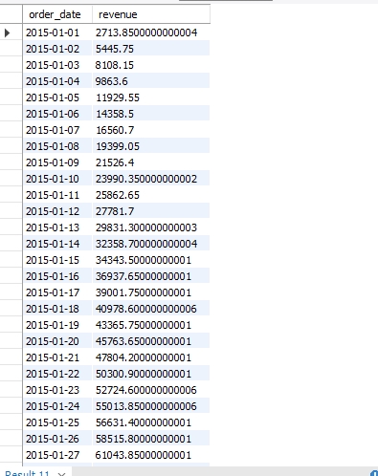

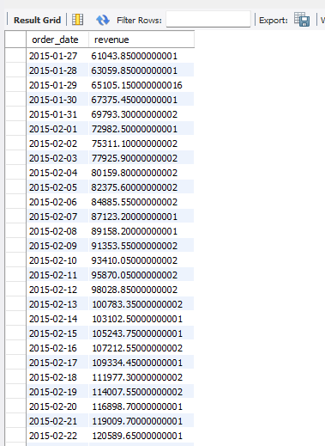

-- Determine the top 3 most ordered pizza types based on revenue for each pizza category

SELECT name, revenue

FROM (

SELECT category, name, revenue,

RANK() OVER (PARTITION BY category ORDER BY revenue DESC) AS rn

FROM (

SELECT pizza_types.category, pizza_types.name,

SUM(order_details.quantity * pizzas.price) AS revenue

FROM pizza_types

JOIN pizzas ON pizza_types.pizza_type_id = pizzas.pizza_type_id

JOIN order_details ON order_details.pizza_id = pizzas.pizza_id

GROUP BY pizza_types.category, pizza_types.name

) AS a

) AS b

WHERE rn <= 3;

